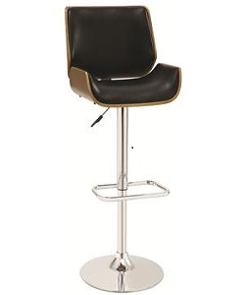

Modern Office Chair

$16.33

Availability: In stock

Description

This furniture features a curved back and seat for comfortable seating and the modern stool design will add a splash of style to your dining area. Set includes: One (1) stool Finish: Walnut/ chrome Seat dimensions: 23-29.5 inches high x 18 inches wide x 18 inches deep Dimensions: 37-43.5 inches high X 20 inches wide x 19.75 inches deep Assembly required. Furniture Pattern: Solid Furniture Room: Dining Room, Kitchen, Bar Material: Wood, Chrome, Faux Leather Style: Transitional Assembly: Assembly Required Set Size: Single Seat Height: Adjustable Exact Color: Black, Cream Color: Black, Cream.